FSGW Board Meeting Minutes Tuesday, February 1, 2011 Final
Attendees: President Mary Cliff, Membership, Program & Events Chair, Marty Summerour, Membership Chair Stephanie Kaufman, Dance Chair Penelope Weinberger, Newsletter Chair Roxanne Watts, Secretary Cat Tucker, At-Large Sue McIver, At-Large Steve Roth,

Absent: Vice-President David Shewmaker, At-Large Member Hannah Platt, Publicity Chair Katie Blaisdell, Treasurer Jerry Stein

Mary officially called the meeting to order at 8:10 pm when we were all gathered.

Minutes for December and “non-minutes” for January were presented. Motions were made by Sue and Roxanne to accept the minutes/non-minutes. Motions passed.

Treasurer’s Report:
- Treasurer sent a message to say that we remain solvent.
- Board Liability Insurance + need for van policy – holding
  - Marty has contacted our insurance agent and has scheduled a meeting with him. It is imperative that we come up with a policy for renting the van and develop paperwork which gathers appropriate information from borrowers of the van.
  - ACTION ITEM: We will develop a policy and appropriate paperwork that gathers pertinent information from the van borrower.
Membership Report:
- We have 2,044 members, down 100 from January
  - It appears that not many members are not updating their info on the website
    - Someone approached Stephanie at the dance and told her that he could access others’ info in addition to his own. That glitch that allowed that improper access has been corrected.
  - 326 people receive electronic newsletters.
  - 1,400 members receive Roxanne’s weekly reminders e-mail
  - Renewal letter is sent out by Alice, but she is not aware of how the “merging” process works.
    - The Board agreed that the renewal letter needs to be revised and updated
    - ACTION ITEM: Work on updating the renewal letter.
Dance Report:
- We now have the English Country contract with G.E. Town Hall and Mary is giving the copy to Penelope
- Penelope has put the wheels in motion to begin advertising for ContraStock. She is hoping that GEPPAC will allow us to use the advance sales option. Maximum capacity of ballroom is 600.
  - ACTION ITEM: Contact GEPPAC requesting permission for advance sales to ContraStock.
- Ed VandenBosche has requested FSGW sponsorship of a Laurel dance event.
  - There was no Board interest in this event.
- We have no contract from the Artisphere for the Contra Sonic dances.
- Nils Fredland will be calling for Contra Sonic in March.
- Elixir will be playing at the free-to-members dance in May.
Newsletter Report:
- Deadline for March newsletter is February 10th.
- Important that we be able to bring newsletters to ALL FSGW events.
- Artisphere has agreed to display our newsletters regularly.
- The month of April is National Volunteer month – would be great to have our volunteers acknowledge in that issue of the newsletter.
- Newsletter printer & continuity
  - Currently costs only 65 cents per issue printed
Publicity Report:
- Two stories in the DC Examiner brought in lots of people for the Hot Seats concert
- We’ve gotten lots of interest in the manifest.
  - Katie, Linda and April are working on a Fox 5 MidWinter segment that will run at 8:45 am on Friday.
- Our latest Facebook ad was seen 308,000 times by people who are NOT already connected to FSGW on Facebook.
- Event ads connect people to the main FSGW page as well as our website, so could generate membership interest.
  - 53 people actually clicked on the ad to see the event details.
Program/Events Report:
- Marty has received requests from members for many new programs for the new year.
Old Business:
- Pat McGee has moved/is moving out of state. Need to liaise with him to retrieve the equipment that was recently purchased.
- The Washington Folk Festival Committee is still looking for a volunteer coordinator.
- Web Committee: Motion was made by Steve Roth to make new Web Committee member, Sandy Aubin, co-chair of the committee. Motion was 2nd by Marty. Motion passed. Penelope abstained.
  - It was noted in discussions that April Blum, current Web Committee Chair, fully supports this.
    - Motion was made by Penelope and 2nd by Sued to approve Nominating Committee members: Colleen Reed with Laura Parsons and Charlie Bean. Motion passed.
    - Please be ready to communicate your willingness or lack, thereof, to run for another term.
New Business
- No new business

Next meeting: Tuesday, March 1, 2011 at Glen Echo.

The meeting was adjourned at 9:19 pm (Motion to adjourn was made by Sue, 2nd by Roxanne., motion passed.)
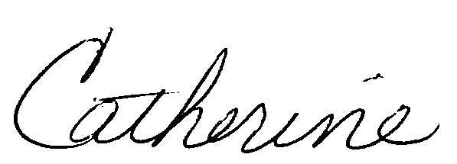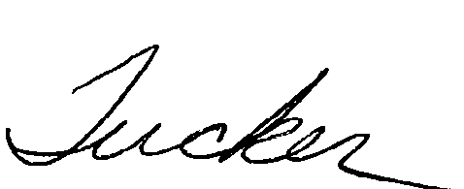
Respectfully submitted by Cat Tucker

